W-15
YEAR 10 SCIENCE (EXTENSION)
PHYSICAL SCIENCES
REVISION

1. (a) Distinguish between the following terms.

(i) Distance and displacement.
(ii) Speed and velocity.

(b) A man drives his car 8.00 x 10² m due East for 2.10 mins and then turns North,
driving 3.00 x 10² m in 1.35 mins before stopping at a petrol station.

(i) Calculate the average speed for the entire motion.
(ii) Calculate the displacement made from home to the petrol station. Show your
working clearly.
(iii) Determine the average velocity for the entire motion.

2. A group of students produced the following ticker tape. One dot is recorded every
0.02 seconds.

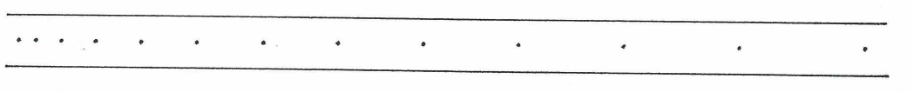

(a) Describe the type of motion shown by the tape.
(b) Analyse the tape and calculate a value for the motion shown. Show your working.

3. A car moves off from a standing start with a uniform acceleration. It reaches 20.0 ms⁻¹ after
8.00 s before maintaining its speed for another 15.0 s. As it approaches a set of lights, it
brakes uniformly to 8.00 ms⁻¹ over 12.0 s. It maintains this velocity as it moves through the
lights, which turned green as it approached..
(Assume the movement has occurred on a straight road.)

(a) Draw a velocity - time graph for the entire motion.
(b) By finding the gradient, calculate:

(i) the acceleration at the start of the motion.
(ii) the deceleration as the car approached the second set of lights.

(c) From the graph, determine the displacement of the car over 40.0 s of the motion.

4. A balloon filled with hydrogen gas has a constant velocity of 40.0 ms⁻¹ East. How long will
it take to go 4.50 x 10² m ?

5. A car of mass 1.53 x 10³ kg is travelling at 70.0 kmh⁻¹ along Hepburn Avenue when the
driver has to brake sharply to avoid a small child who suddenly appeared on a bike crossing
the road. The car slowed to 20.0 kmh⁻¹ in 3.20 s and managed to miss the child, who made
it across safely.

(a) Calculate the average force exerted by the brakes.
(b) How far did the car travel while braking?
(c) The driver of the car was an engineer and had a hard-hat sitting on the back shelf.
Describe what happened to the hard-hat in this situation and explain why it took
place.

6. (a) Explain the difference between mass and weight. Give an example to help your
explanation.
(b) The acceleration due to gravity on Jupiter is 22.5 ms⁻². Calculate the weight of a
4.50 x 10² kg object on Jupiter.
(c) A Canadian astronaut is working on the International Space Station. He is able to
float freely about the cabin, moving easily about with little pushes off the walls.
During a link-up with students from an Australian school, one student asked him
what it felt like to be weightless. The student was surprised when he replied "I'm
not weightless so I can’t tell you". Was he correct to say this? Explain your answer.

7. A 70.0 kg cyclist is applying a force of 1.50 x 10² N forwards but is working against a wind
producing a friction force of 80.0 N opposing the movement.

(a) Calculate the acceleration of the cyclist.
(b) It is possible for the rider to move at constant velocity. In terms of the forces acting,
explain how this is possible.

8. You are sitting on a chair at the moment. Explain why you don't fall through the chair and
are supported by it.

9. Write the following in scientific notation and with standard units (kg, m, s).

(a) 0.0293 mm (b) 3652 kg (c) 38.6 minutes
(d) 495 million km (e) 70.0 kmh⁻¹ (f) 75 mg

10. Perform the following calculation, expressing the answer to the correct number of significant figures.

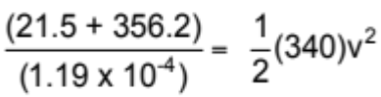

11. (a) What is a scalar and a vector?
(b) Give two examples of each.

12. During a stunt for a film, a 90.0 kg person leaps from a plane at 5,000 m above the ground. He maintains a streamlined body shape to minimise air resistance. Ignoring any friction, calculate the following.

(a) How far has the person fallen after 18.0 s?
(b) How fast is he travelling at this point?
(c) The stunt person deploys a parachute that reduces his velocity to 25.0 ms⁻¹ in 90.0 m.
Calculate the force exerted by the parachute.
(Hint - calculate acceleration first.)

13. An electron of mass 9.11 x 10⁻³¹ kg is accelerated from rest to 2.45 x 10⁷ ms⁻¹ over a distance of 3.00 cm in an electric field.

(a) Calculate the magnitude of the acceleration of the electron. Does this surprise you?
Comment on this.
(b) Consider the size of the force required to accelerate the electron. Are you surprised by
its magnitude? Comment on this.

